**Robotics and Automation class**

# **personal project**

1. **Project definition**

**Author:** Tony Kabeberi

**Date:** 29/06/2023

**Version:** V 1.0

**Topic: Using DHT sensor to check temperature and humidity of the environment of a Robot.**

**Objectives: The objective of this IoT & Robotics project is to utilise a DHT sensor to accurately measure and monitor the temperature and humidity levels in the environment surrounding a robot. By integrating the sensor with the robot’s system, we aim to develop a robust solution that enables real-time data collection, analysis, and appropriate adjustment to optimize the robot’s performance and ensure its operation within specified environmental conditions. This project seeks to enhance the robot’s capabilities by providing valuable environment insights, facilitating efficient decision-making processes, and contributing to overall operational efficiency and reliability.**

1. **Project Design.**

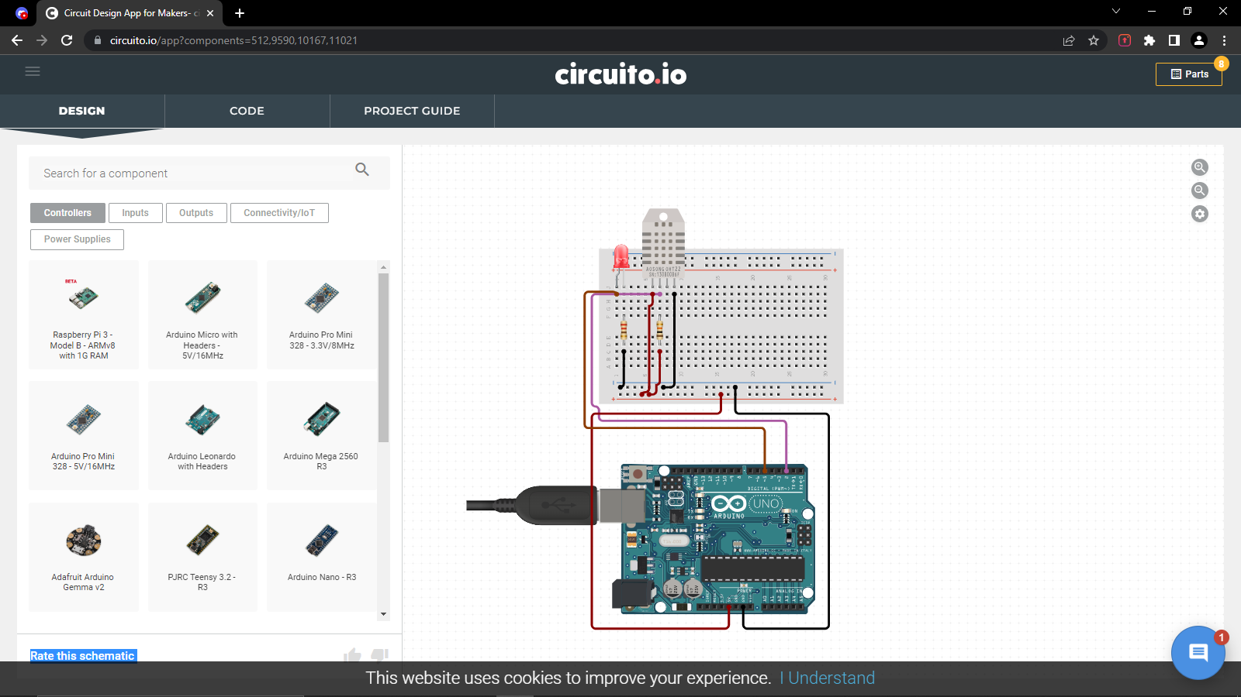

1. **Physically connect the components.**

|  |  |  |
| --- | --- | --- |
| **Wire** | **DHT** | **MCU** |
| **Purple** | **+ or +ve** | **VCC** |
| **brown** | **OUT** | **D2** |
| **Pink** | **- or GND** | **GND** |

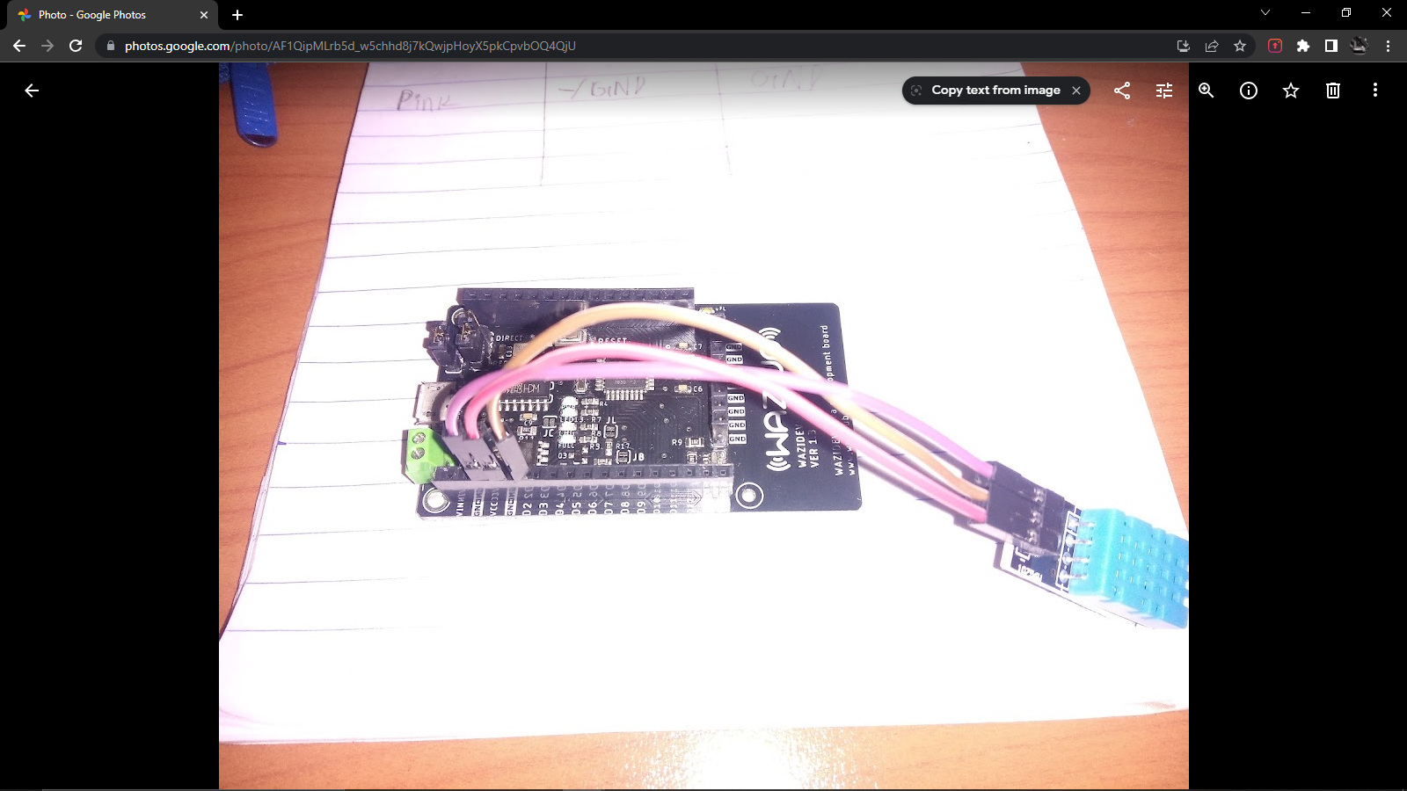

1. **Program the microcontroller.**
2. **Observe and report.**